Garden City Chiropractic
New Practice Member Paperwork
Name__________________________________ Today’s Date____/____/____ Age_____ Male/Female
Address______________________________________City____________________State_____Zip__________
Primary Contact #: ____________________ Home ( ) Cell ( ) Work ( ) Date of Birth_____/_____/______
Email __________________________________ Cell Carrier: ________________
Occupation___________________________________ Employer’s Name _____________________________
Single / Engaged / Married / Divorced / Widowed Spouse’s Name (or Parent if a minor) _______________
# of Children______ Names, Ages & Gender______________________________________________________
Who may we thank for referring you to us? _____________________________________________________
LIST YOUR HEALTH CONCERNS BELOW

Health Concerns:  List according to severity | Rate of Severity  1 = mild  10 = unbearable | When did  this episode start? | If you had the condition before, when? | Did the problem begin with an injury? | Are symptoms constant or intermittent?
1. __________________________ _________________ ______________ _________________ ________________ ____________
2. __________________________ _________________ ______________ _________________ ________________ ____________
3. __________________________ _________________ ______________ _________________ ________________ ____________
4. __________________________ _________________ ______________ _________________ ________________ ____________
5. __________________________ _________________ ______________ _________________ ________________ ____________
HOW ARE THESE CONCERNS AFFECTING YOUR HOBBIES AND/OR DAILY LIVING? _______________________
__________________________________________________________________________________________
HAVE YOU EVER SEEN OTHER DOCTORS FOR THESE CONDITIONS? YES / NO
CHIROPRACTOR? ________________ MEDICAL DOCTOR? ___________________OTHER________________
WHO AND WHEN?________________________________________________________________________________
CIRCLE ALL CURRENT PROBLEMS YOU HAVE
DIZZINESS | THROAT ISSUES | KIDNEY PROBLEMS | LIVER DISEASE | NERVOUSNESS
HEADACHES | THYROID PROBLEMS | MID BACK PAIN | SHOULDER PAIN | EPILEPSY
VERTIGO | ASTHMA | IRRITABLE BOWEL | CHRONIC FATIGUE | DISC PROBLEM
EAR INFECTIONS | ULCERS | SCIATICA | LUPUS | INFERTILITY
NAUSEA | NUMBNESS IN ARMS | NUMBNESS IN LEGS | FIBROMYALGIA | GASTRIC REFLUX
TMJ | NUMBNESS IN HANDS | NUMBNESS IN FEET | CHEST PAIN
NECK PAIN | MENSTRUAL DISORDER | LOW BACK PAIN | ARM PAIN | OTHER____________
MIGRAINES | HEART DISORDERS | HIP PAIN | ADD/ADHD | __________________
ANXIETY | STOMACH DISORDERS | LEG PAINS | ______________ | __________________
CHRONIC SINUS | BLADDER PROBLEMS | KNEE PAIN | _______________ | __________________
LIST ALL SURGERIES AND YEARS (INCLUDING SPINAL SURGERIES) ______________________________________ __________________________________________________________________________________________
LIST ALL Over the Counter & PRESCRIPTION MEDICATIONS YOU ARE : ________________________________
__________________________________________________________________________________________________
WHEN WAS YOUR LAST AUTO ACCIDENT_____________________________________________________________
HAVE YOU HAD CHIROPRACTIC CARE BEFORE? NO / YES 🡪DR. & DATE: ________________________________
HAVE YOU EVER BEEN KNOCKED UNCONSCIOUS? YES / NO FRACTURED A BONE? YES / NO
IF YES, PLEASE DESCRIBE_____________________________________________________________________
OTHER TRAUMA:___________________________________________________________________________

CIRCLE ANY CONDITION YOU HAVE NOW/ HAVE HAD BELOW:
STROKE | CANCER | HEART DISEASE | SPINAL SURGERY | SEIZURES | SPINAL BONE FRACTURE | SCOLIOSIS | DIABETES

IF THIS HEALTH PROFILE IS FOR A MINOR/CHILD, PLEASE FILL OUT AND SIGN BELOW WRITTEN CONSENT FOR A CHILD
Practice member name who is a minor/child _________________________________
Name of person filling out profile and relationship ______________________________
I authorize Dr. Nicholas Hoar and/or Dr. Mackenzie Hoar and any and all Garden City Chiropractic staff to perform diagnostic procedures, radiographic evaluations, render chiropractic care and perform chiropractic adjustments to my minor/child. As of this date, I have the legal right to select and authorize health care services for my minor/child. If my authority to select and authorize care is revoked or altered, I will immediately notify Garden City Chiropractic.

Please Circle: I DO / DO NOT authorize my child to drive themselves or be brought by another family member or friend to receive recommended chiropractic adjustments or reassessments throughout their care.

____________________________ ________________________________________
^{DATE} ^{GUARDIAN SIGNATURE}
________________________________ _____________________________________________
^{WITNESS SIGNATURE} GUARDIAN’S RELATIONSHIP TO MINOR / CHILD
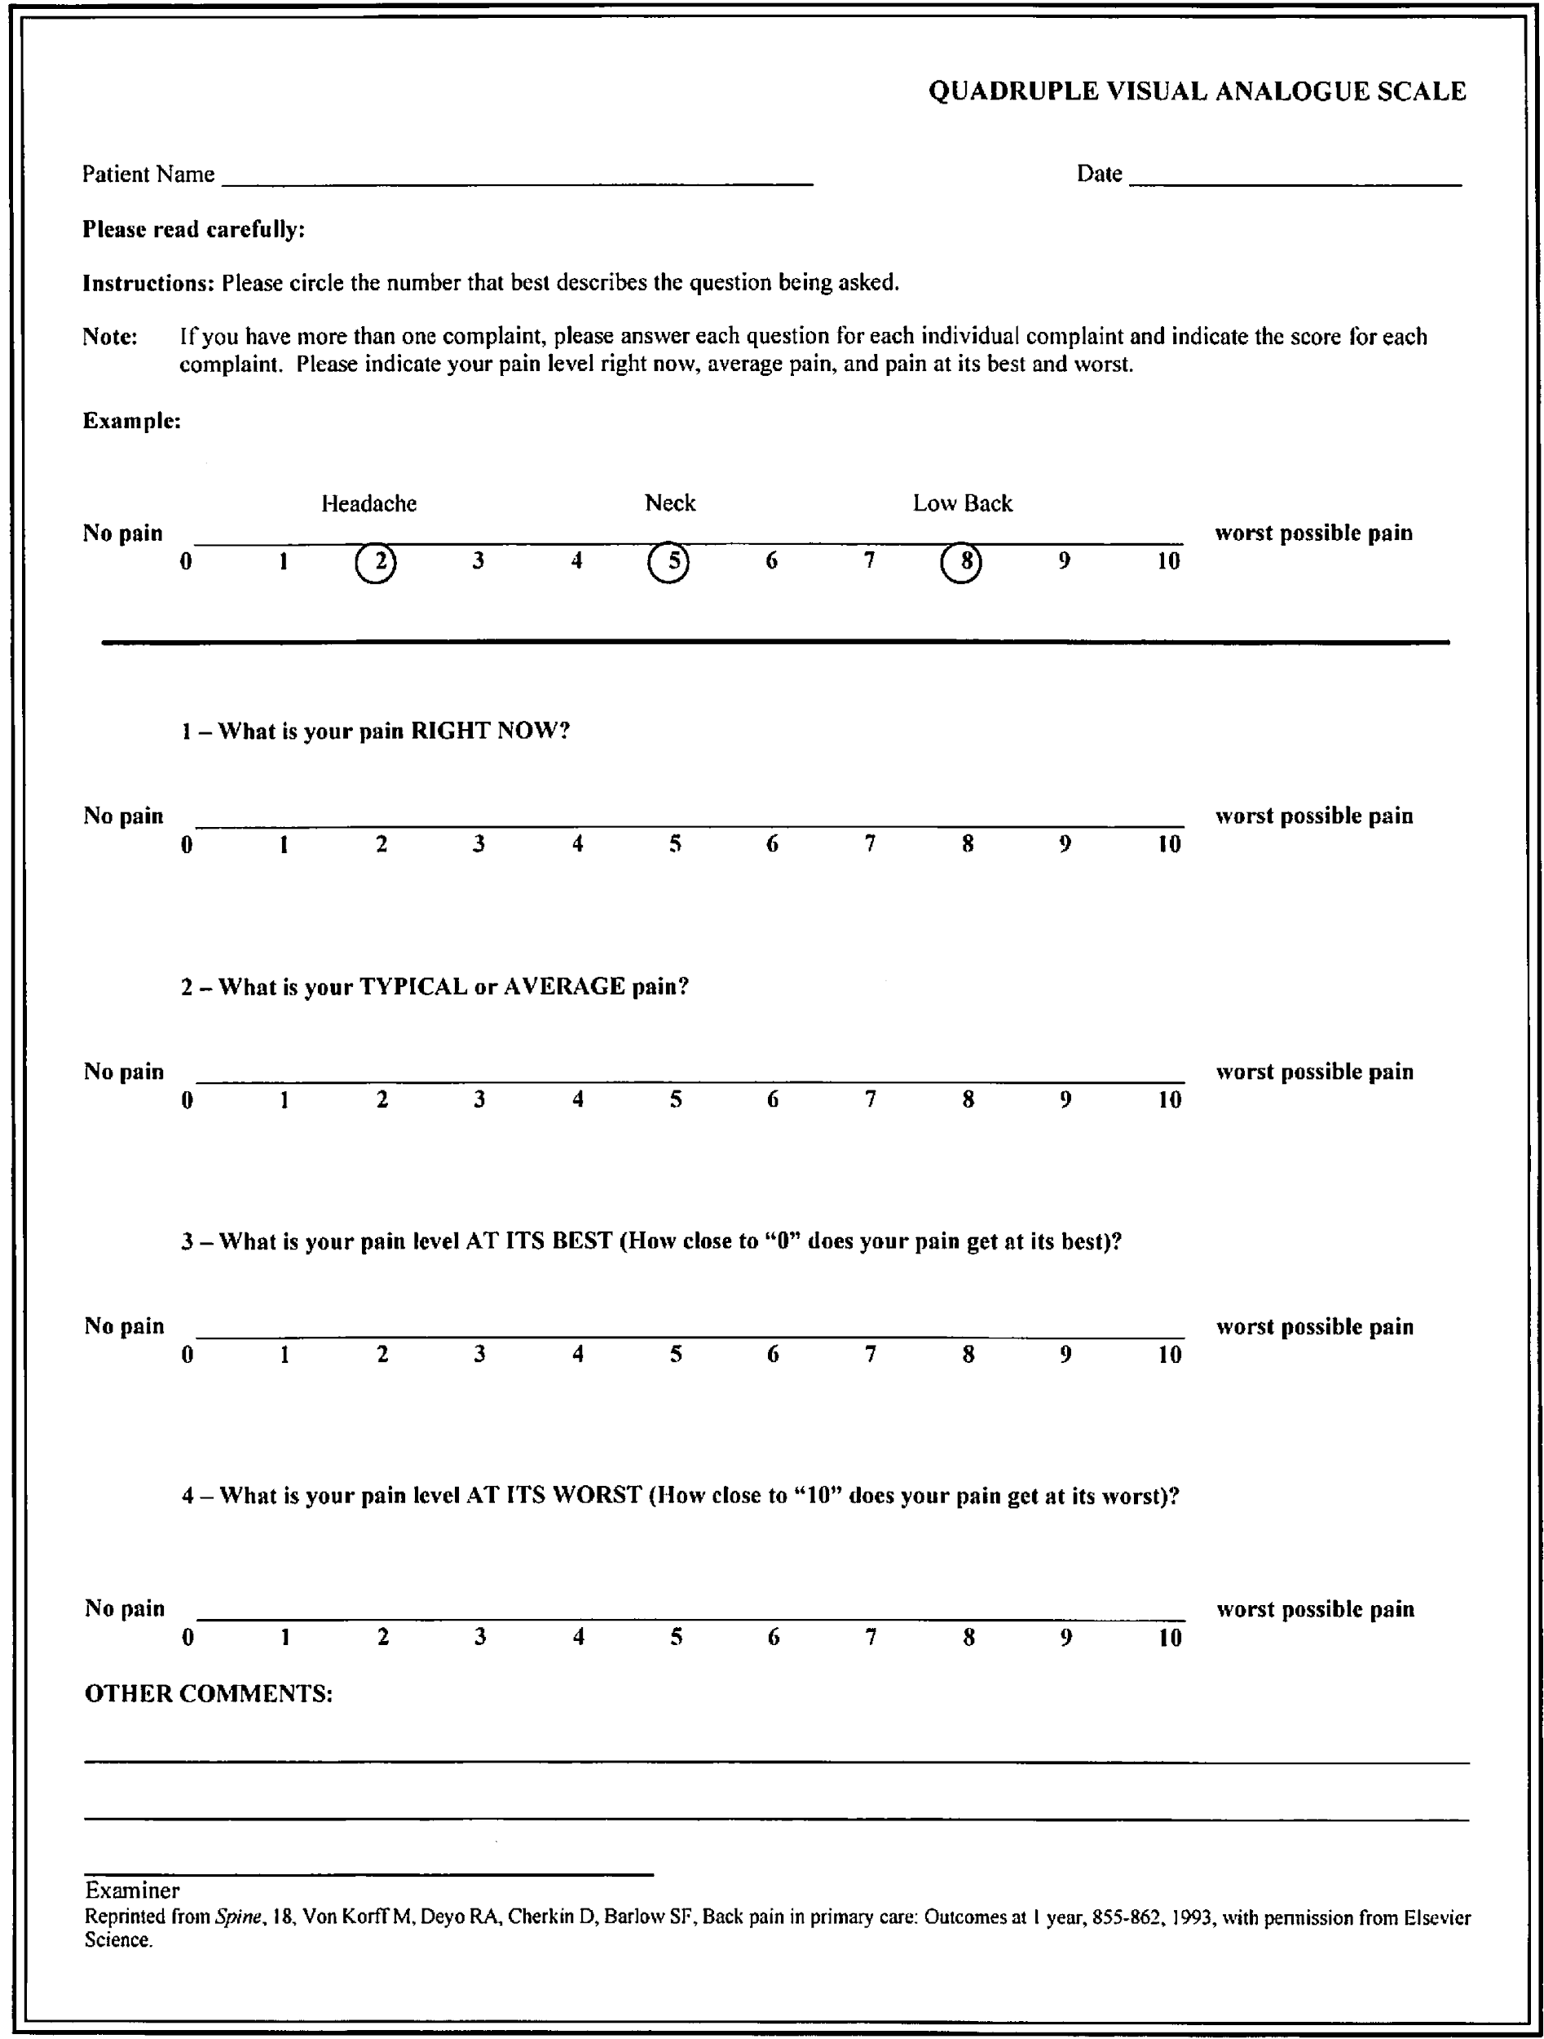
FAMILY HEALTH HISTORY
THIS FORM IS TO ASSIST THE DOCTORS BY PROVIDING PAST HEALTH HISTORY INFORMATION
FOR THEIR REVIEW.

_______________________________ _______________________________________________
^{DATE} ^{PLEASE PRINT YOUR NAME HERE}
CONDITION | SPOUSE | SON | DAUGHTER | MOTHER | FATHER
ARM PAIN
ARTHRITIS
ASTHMA
ADD/ADHD
ALLERGIES
BACK TROUBLE
BED WETTING
CANCER
CARPAL TUNNEL
DECEASED
DIABETES
DIGESTIVE PROBLEMS
DISC PROBLEMS
EAR INFECTIONS
FIBROMYALGIA
HEADACHES
HEARTBURN
HIGH BLOOD PRESSURE
HIP PAIN
LEG PAIN
MENSTRUAL DISORDER
MIGRAINES
NECK PAIN
SCOLIOSIS
SHOULDER PAIN
SINUS TROUBLE
TMJ

X-RAY AUTHORIZATION

AS YOUR HEALTHCARE PROVIDER, WE ARE LEGALLY RESPONSIBLE FOR YOUR CHIROPRACTIC RECORDS. WE MUST MAINTAIN A RECORD OF YOUR X-RAYS IN OUR FILES.
AT YOUR REQUEST, WE WILL PROVIDE YOU WITH A COPY OF YOUR X-RAYS IN OUR FILES.

PLEASE NOTE: X-RAYS ARE UTILIZED IN THIS OFFICE TO HELP LOCATE AND ANALYZE VERTEBRAL SUBLUXATIONS.
THESE X-RAYS ARE NOT USED TO INVESTIGATE FOR MEDICAL PATHOLOGY. THE DOCTORS OF GARDEN CITY CHIROPRACTIC DO NOT DIAGNOSE OR TREAT MEDICAL CONDITIONS; HOWEVER, IF ANY ABNORMALITIES ARE FOUND, WE WILL BRING IT TO YOUR ATTENTION SO THAT YOU CAN SEEK PROPER MEDICAL ADVICE.
BY SIGNING BELOW YOU ARE AGREEING TO THE ABOVE TERMS AND CONDITIONS..

__________________________________________ _______________________
^{PRINT YOUR NAME HERE} ^{DATE}

__________________________________________ _______________________
^{SIGNATURE} ^{YOUR AGE}

FEMALE PATIENTS ONLY: TO MY KNOWLEDGE, I BELIEVE (CIRCLE ONE) I AM NOT PREGNANT / I AM PREGNANT
AT THE TIME X-RAYS ARE TAKEN AT GARDEN CITY CHIROPRACTIC. BY SIGNING BELOW, I CONSENT TO X RAYS TAKEN OF THE AGREED-UPON SPINAL REGIONS ONLY.

__________________________________________ _______________________
^{SIGNATURE} ^{DATE}
DO NOT WRITE BELOW THIS LINE

Sex: ☐ M ☐ F
☐ Lat Cervical ☐ Flex/Ext  CM Kvp Time MAS  ☐10-11 ☐78 ☐1/24 12.5  ☐12-13 ☐1/20 15  ☐14-15 ☐1/15 20  ☐16-17 ☐1/10 30  ☐2/15 40  MA 200 Size 8x10 | ☐ Lower Cervical  CM Kvp Time MAS  ☐14-15 ☐70 ☐1/10 20  ☐16-17 ☐ ☐2/15 30  ☐18-19 ☐3/20 40  ☐20-21 ☐2/10 50  ☐22-23  MA 300 Size 8x10 | ☐ Lateral Thoracic  CM Kvp Time MAS  ☐22-23 ☐80 ☐1/10 20  ☐24-25 ☐2/10 30  ☐26-27 ☐2/10 40  ☐28-29 ☐1/4 50  ☐30-31 ☐4/10 75  ☐32-33 ☐1/2 90  ☐34-35 ☐8/10 120  ☐36-37 ☐1 150  MA 200 Size 14x17 | ☐ A-P Thoracic  CM Kvp Time MAS  ☐16-17 ☐75 ☐1/20 17  ☐18-19 ☐1/15 22  ☐20-21 ☐1/10 30  ☐22-23 ☐2/15 40  ☐24-25 ☐2/10 50  ☐26-27 ☐1/4 75  ☐28-29 ☐3/10 90  ☐30-31 ☐2/5 120  MA 200 Size 14x17
☐ APOM  CM Kvp Time MAS  ☐14-15 ☐70 ☐1/10 20  ☐16-17 ☐2/15 30  ☐18-19 ☐3/20 40  ☐20-21 ☐2/10 50  ☐22-23  MA 200 Size 8x10 | Other  View _______________  CM_________ Kvp ________  MAS________ MA________  Size ______________
 |  | ☐ Lateral Lumbar  CM Kvp Time MAS  ☐26-27 ☐88 ☐2/10 30  ☐28-29 ☐88 ☐1/4 40  ☐30-31 ☐88 ☐3/10 50  ☐32-33 ☐88 ☐2/5 70  ☐34-35 ☐88 ☐1/2 90  ☐36-37 ☐90 ☐3/5 120  ☐38-39 ☐92 ☐4/5 160  ☐40-41 ☐94 ☐1 200  ☐42-43 ☐96 ☐1 1/2  ☐ 44-45 ☐ 98 ☐2  MA 200 Size 14x17 | ☐ A-P Lumbar  CM Kvp Time MAS  ☐20-21 ☐80 ☐2/10 40  ☐22-23 ☐80 ☐1/4 50  ☐24-25 ☐80 ☐4/10 75  ☐26-27 ☐80 ☐1/2 90  ☐28-29 ☐80 ☐4/5 120  ☐30-31 ☐80 ☐4/5 150  ☐32-33 ☐80 ☐4/5 120  ☐34-35 ☐80 ☐1 170  ☐36-37 ☐80 ☐1 210  ☐38-39 ☐80 ☐1 1/2  ☐40-41 ☐82 ☐2  ☐42-43 ☐ 82 ☐2  ☐ 44-45 ☐ 84 ☐3  MA 200 Size 14x17
Notes: ___________________________________
_________________________________________
_________________________________________
_________________________________________
_________________________________________
_________________________________________
_________________________________________
 |  | CA Initials: ___________

Practice Member Information (Must be Completed Before Services Can Be Rendered)

NAME: __________________________________________________________________________________
^{FIRST} ^{MIDDLE} ^{LAST}

PHONE: Home______________________ Cell______________________ Work__________________

SOCIAL SECURITY NUMBER: _____________________ MARITAL STATUS: ____________

DATE OF BIRTH: _____________________

CONTACT IN CASE OF EMERGENCY: _________________________ Phone #: _________________

NAME OF PRIMARY INSURANCE CARRIER: ________________________________________________

Name of Insured_________________________ Insured Date of Birth __________________

Insured Social Security Number __________________

NAME OF SECONDARY INSURANCE CARRIER: _____________________________________________

Name of Insured_________________________ Insured Date of Birth __________________

Insured Social Security Number: __________________

Insurance Policies and Fee Schedule

- Consultation- includes practice member history. This service is complimentary
- Assessment (new or established practice member)- includes one or more of the following: thermography, surface electromyography, range of motion, motion and/or static palpation, leg check $50-$75.
- Chiropractic Adjustment- The actual re-alignment of the vertebra done by hand. Often a sound will be heard, but if there is no auditory result, it does not mean that the adjustment has not taken place. $40-$60.
- X-rays- Specific x-ray views taken of your spine to determine a misalignment/subluxation of your vertebrae. These can also be used to indicate progress after a period of care. $40 per view.

Release of Authorization/Assignment of Benefits
I authorize and request payment of insurance benefits directly to Nicholas Hoar, DC or Mackenzie Hoar, DC. I agree that this authorization will cover all services rendered until I revoke the authorization. I agree that a photocopy of this form may be used in place of the original. All professional services rendered are charged to the patient. It is customary to pay for services when rendered unless other arrangements have been made in advance. I understand that I am financially responsible for charges not covered by this assignment.

Signed_______________________________________________ Date___________________

Terms of Acceptance

In order to provide for the most effective healing environment, most effective application of chiropractic procedures, and the strongest possible doctor-patient relationship, it is our wish to provide each patient with a set of parameters and declarations that will facilitate the goal of optimum health through chiropractic.

To that end, we ask that you acknowledge the following point regarding chiropractic care and the services that are offered through this clinic:

- Chiropractic is a very specific science, authorized by law to address spinal health concerns and needs. Chiropractic is a separate and distinct science, art and practice. It is not the practice of medicine.
- Chiropractic seeks to maximize the inherent healing power of the human body by restoring normal nerve functions through the adjustment of spinal subluxation(s). Subluxations are deviations from normal spinal structures and configurations that interfere with normal nerve processes.
- The chiropractic adjustment process, as defined in the law of this jurisdiction, involves the application of a specific directional thrust to a region or regions of the spine with the specific intent of re-positioning misaligned spinal segments. This is a safe, effective procedure applied over one million times each day by doctors of chiropractic in the United States alone.
- A thorough chiropractic examination and evaluation is part of the standard chiropractic procedure. The goal of this process is to identify any spinal health problems and chiropractic needs. If during this process, any condition or question outside the scope of chiropractic is identified, you will receive a prompt referral to an appropriate provider or specialist, according to the initial indications of the need.
- Chiropractic does not seek to replace or compete with your medical, dental or other type(s) of health professionals. They retain responsibility for care and management of medical conditions. We do not offer advice regarding treatment prescribed by others.
- Your compliance with care plans, home and self-care, etc., is essential to maximum healing and optimal health through chiropractic
- We invite you to speak frankly to the doctor on any matter related to your care at this facility, its nature, duration, or cost, in what we work to maintain as a supporting, open environment.

By my signature below, I have read and fully understand the above statements.

All questions regarding the doctor’s objectives pertaining to my care in this office have been answered to my satisfaction. I therefore accept chiropractic care on this basis.

___________________________________________ ____________________________
^{(Signature)} ^{(Date)}

Notice of Privacy Practices Acknowledgement
I understand that I have certain rights of privacy regarding my protected health information, under the Health Insurance Portability & Accountability Act of 1996 (HIPAA). I understand that this information can and will be used to:
- Conduct, plan and direct my treatment and follow-up among the multiple healthcare providers who may be involved in that treatment directly and indirectly.
- Obtain payment from third-party payers.
- Conduct normal healthcare operations, such as quality assessments and physicians certifications.

I acknowledge that I may request your NOTICE OF PRIVACY PRACTICES containing a more complete description of the uses and disclosures of my health information. I also understand that I may request, in writing, that you restrict how my private information is used to disclose to carry out treatment, payment, or healthcare operation. I also understand you are not required to agree to my requested restrictions, but if you agree, then you are bound to abide by such restrictions.

___________________________________________ ____________________________
^{(Signature)} ^{(Date)}

INFORMED CONSENT FOR CHIROPRACTIC CARE

CHIROPRACTIC CARE, LIKE ALL FORMS OF HEALTH CARE WHILE OFFERING CONSIDERABLE BENEFITS MAY ALSO PROVIDE SOME LEVEL OF RISK. THIS LEVEL OF RISK IS MOST OFTEN VERY MINIMAL, YET IN RARE CASES, INJURY HAS BEEN ASSOCIATED WITH CHIROPRACTIC CARE. THE TYPES OF COMPLICATIONS THAT HAVE BEEN REPORTED SECONDARY TO CHIROPRACTIC CARE INCLUDE: SPRAIN/STRAIN INJURIES, IRRITATION OF A DISC CONDITION, AND RARELY, FRACTURES. ONE OF THE RAREST COMPLICATIONS ASSOCIATED WITH CHIROPRACTIC CARE OCCURRING AT A RATE BETWEEN ONE INSTANCE PER ONE MILLION TO ONE PER TWO MILLION CERVICAL SPINE (NECK) ADJUSTMENTS MAY BE A VERTEBRAL INJURY THAT COULD LEAD TO A STROKE.

PRIOR TO RECEIVING CHIROPRACTIC CARE IN THIS CHIROPRACTIC OFFICE, A HEALTH HISTORY AND PHYSICAL EXAMINATION WILL BE COMPLETED. THESE PROCEDURES ARE PERFORMED TO ASSESS YOUR SPECIFIC CONDITIONS, YOUR OVERALL HEALTH AND IN PARTICULAR YOUR SPINAL HEALTH. THESE PROCEDURES WILL ASSIST US IN DETERMINING IF CHIROPRACTIC CARE IS NEEDED, OR IF ANY FURTHER EXAMINATIONS OR STUDIES ARE NEEDED. IN ADDITION, THEY WILL HELP US DETERMINE IF THERE IS ANY REASON TO MODIFY YOUR CARE OR PROVIDE YOU WITH A REFERRAL TO ANOTHER HEALTH CARE PROVIDER. ALL RELEVANT FINDINGS WILL BE REPORTED TO YOU ALONG WITH A CARE PLAN PRIOR TO BEGINNING CARE.

I UNDERSTAND AND ACCEPT THAT THERE ARE RISKS ASSOCIATED WITH CHIROPRACTIC CARE AND GIVE CONSENT TO THE EXAMINATION THAT THE DOCTOR DEEMS NECESSARY AND THE CHIROPRACTIC CARE, INCLUDING SPINAL ADJUSTMENTS, AS REPORTED FOLLOWING MY ASSESSMENT.

__________________________________________
PRINT PRACTICE MEMBER’S NAME HERE

__________________________________________ _______________________
^{PRACTICE MEMBER’S SIGNATURE} ^{DATE}

IF PRACTICE MEMBER IS A MINOR/CHILD, PARENT OR GUARDIAN MUST SIGN BELOW.

__________________________________________ _______________________
SIGNATURE OF PRACTICE MEMBER OR GUARDIAN ^{DATE}

__________________________________________
^{RELATIONSHIP TO MINOR/CHILD}

__________________________________________ _______________________
WITNESS SIGNATURE (OFFICE STAFF) ^{DATE}

